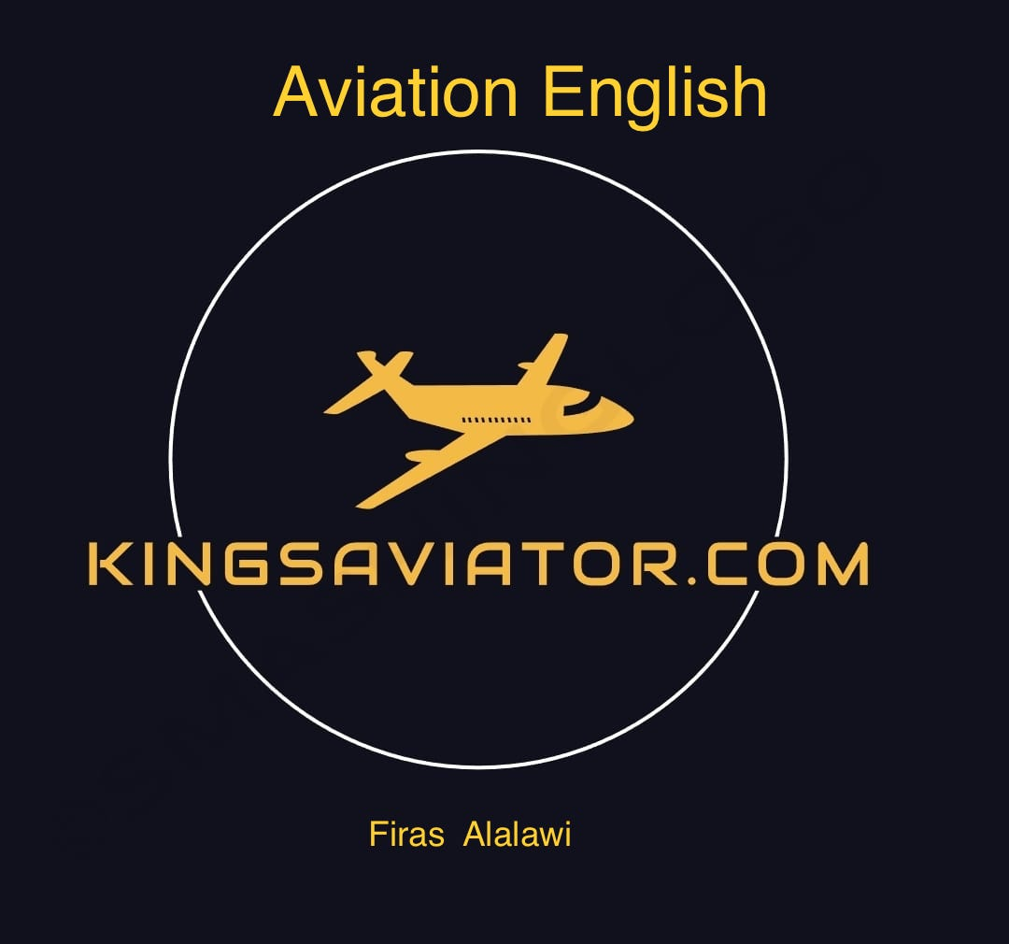

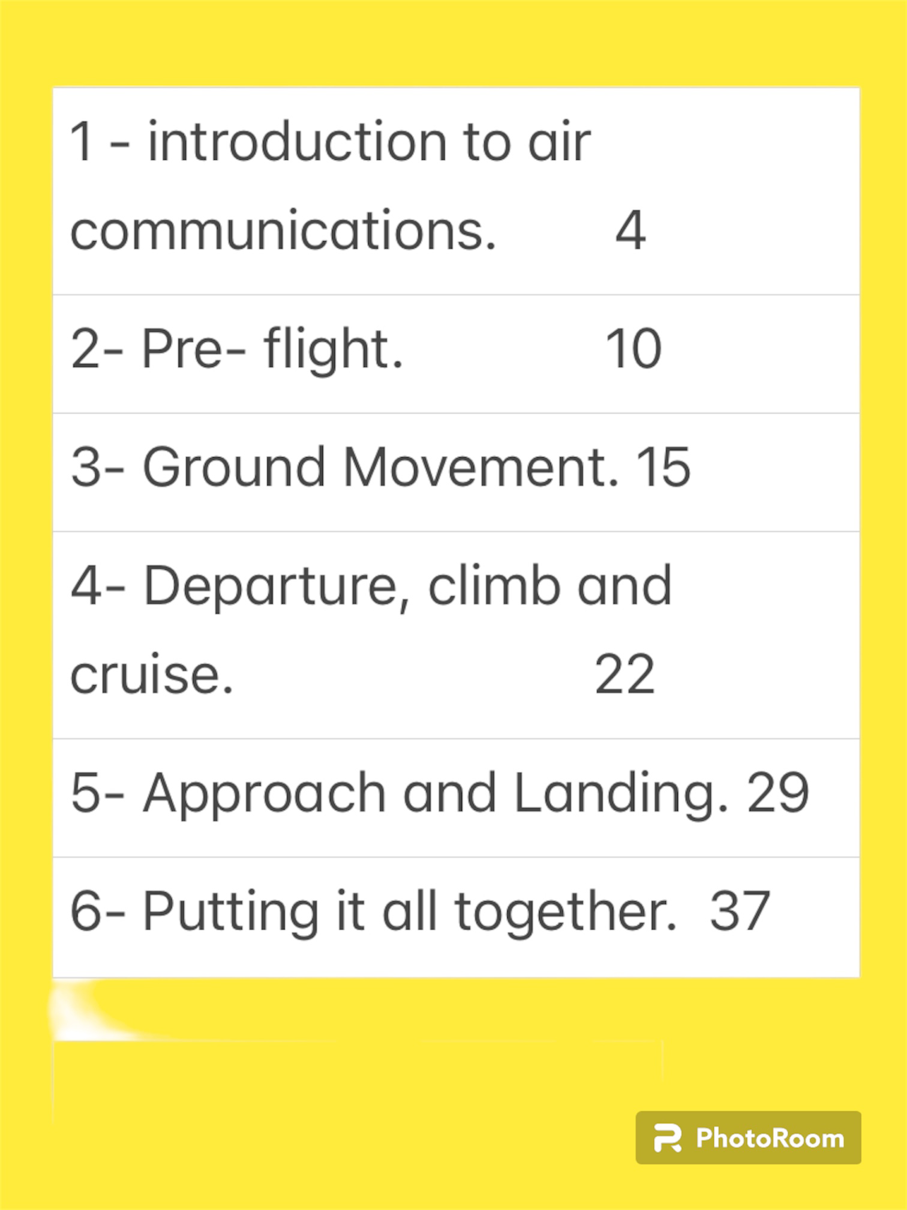

Left intentionally blank

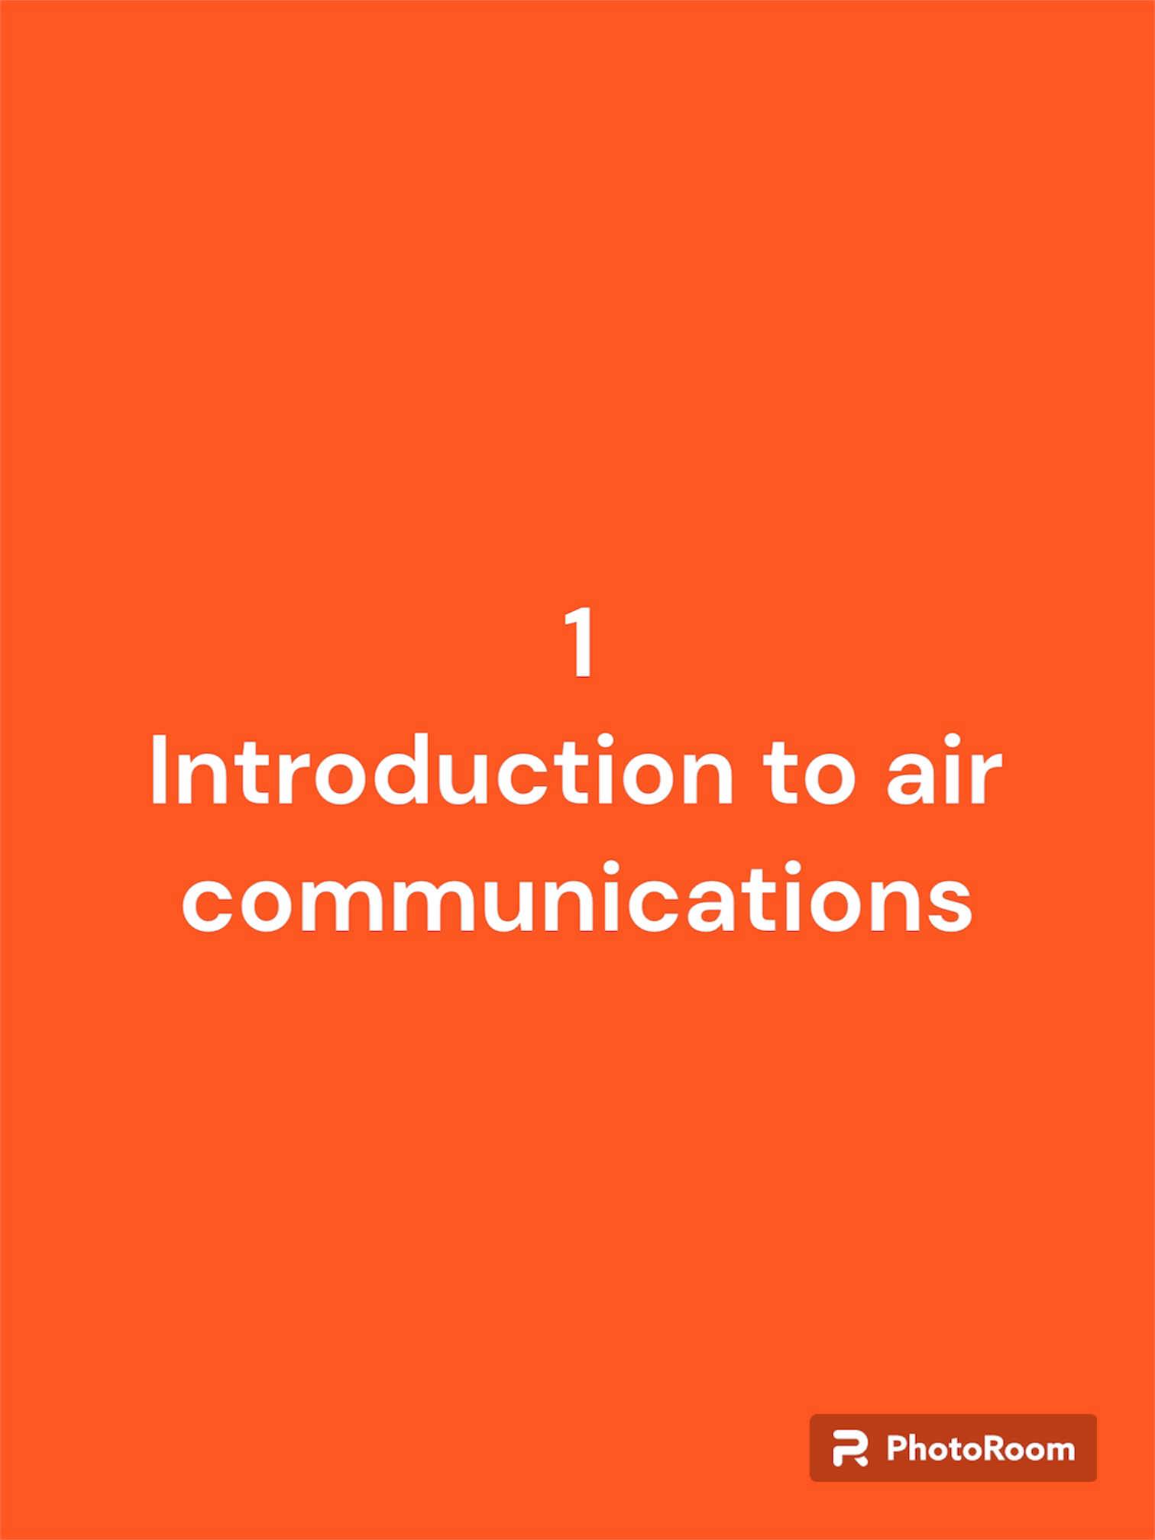
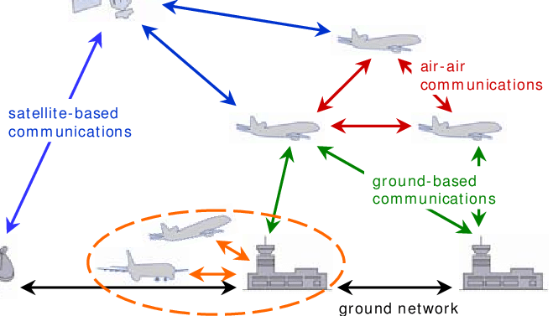
- Introduction to Air communications:

Aviation communication refers to the specialised methods and systems used by pilots, air traffic controllers, and aviation personnel to exchange information and instructions. This communication is crucial for the safe and efficient operation of aircraft in the airspace. It typically involves radio transmissions, radar data, and various standard phrases and protocols to convey information about flight status, navigation, weather conditions, and more. Effective aviation communication is vital to ensure the safety and coordination of air traffic.

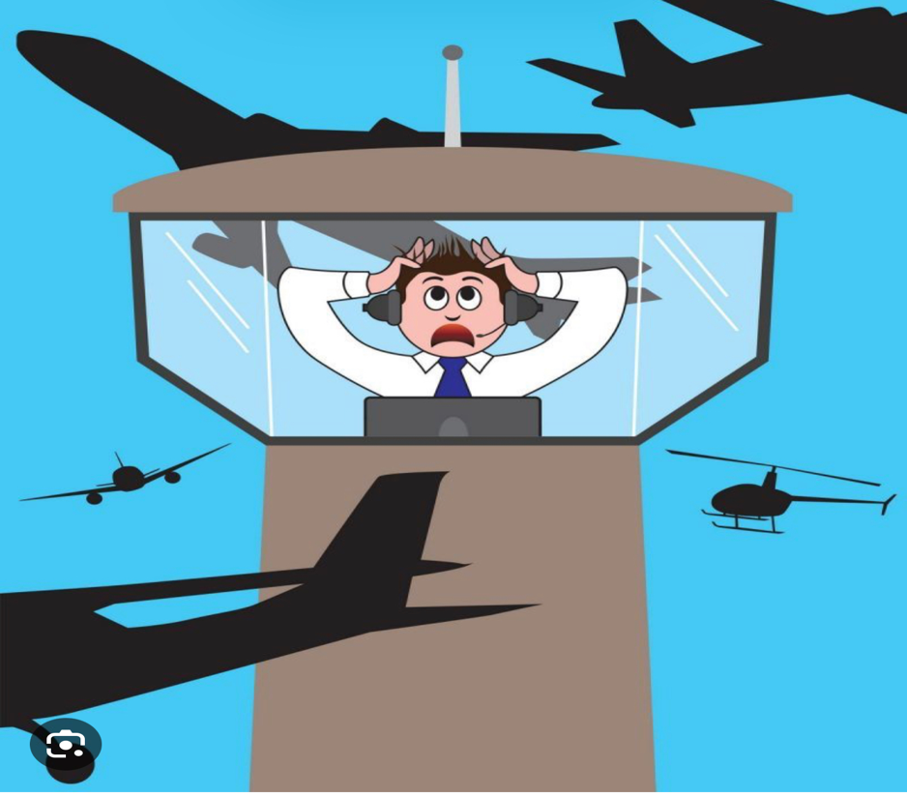
The International Civil Aviation Organization (ICAO) has established language proficiency requirements for pilots and air traffic controllers. The ICAO Language Proficiency Requirements are outlined in ICAO Annex 1 - Personnel Licensing.

According to these requirements, pilots must demonstrate English language proficiency at the operational level, which means they should be able to communicate effectively in routine and non-routine situations. This includes understanding and responding appropriately to both clear and ambiguous communication, as well as being able to communicate effectively in both normal and emergency situations.

Language proficiency is assessed on a scale of six levels, ranging from Level 1 (Pre-Elementary) to Level 6 (Expert). Pilots are required to achieve at least Level 4 proficiency to obtain or renew their pilot licenses. Level 4 indicates operational English language proficiency.

It's important for pilots to undergo language assessments periodically, and their language proficiency level must be maintained throughout their career. The specific regulations and procedures for language proficiency testing may vary slightly between aviation authorities, but they generally adhere to the ICAO standards.

Standard Phraseology and Radio Discipline
Pilots use standardized phraseology to ensure clear and unambiguous communication. Standard phraseology includes specific terms, formats, and acronyms for various communications, such as requests, clearances, position reports, and emergency declarations.
Radio discipline involves adhering to strict communication protocols, including maintaining proper frequency usage, avoiding unnecessary transmissions, and respecting ATC instructions and priorities.

Icao Alphabet and numbers
The ICAO (International Civil Aviation Organization) alphabet, also known as the NATO phonetic alphabet, is a standardized system used for clear and consistent verbal communication of letters and numbers in aviation and other fields. Here are the ICAO alphabet for letters and numbers:

Letters: | Numbers:
A -Alpha. | 0 - Zero
B- Bravo | 1 - One
C - Charlie | 2 - Two
D - Delta | 3 - Three
E - Echo | 4 - Four
F - Foxtrot | 5 - Five
G - Golf | 6 - Six
H - Hotel | 7 - Seven
I - India | 8 - Eight
J - Juliett | 9 - Nine
K - Kilo
L - Lima
M - Mike
N - November
O - Oscar
P - Papa
Q - Quebec
R - Romeo
S - Sierra
T - Tango
U - Uniform
V - Victor
W – Whiskey
X - X-ray
Y - Yankee
Z - Zulu

These standardized phonetic representations help eliminate confusion when communicating over the radio, especially in situations where the spoken words might be easily misunderstood, such as in noisy or stressful environments.

Abbreviations:

These abbreviations are commonly used in aviation to convey information efficiently and precisely. The aviation industry relies on standardized terminology for clear and safe communication.

1. A/C - Aircraft
2. ADF - Automatic Direction Finder
3. AGL - Above Ground Level
4. AOA - Angle of Attack
5. ALT - Altitude
6. AP - Auxiliary Power Unit
7. ATC - Air Traffic Control
8. CAT - Clear Air Turbulence
9. CVR - Cockpit Voice Recorder
10. EGT - Exhaust Gas Temperature
11. ELT - Emergency Locator Transmitter
12. FAA - Federal Aviation Administration
13. FBO - Fixed-Base Operator
14. FDR - Flight Data Recorder
15. FL - Flight Level
16. GS - Groundspeed
17. GCA - Ground-Controlled Approach
18. GPS - Global Positioning System
19. IAS - Indicated Airspeed
20. IFR - Instrument Flight Rules
21. ILS - Instrument Landing System
22. ILS - Instrument Landing System
23. MEL - Minimum Equipment List
24. METAR - Meteorological Aerodrome Report
25. MRO - Maintenance, Repair, and Overhaul
26. MSA - Minimum Safe Altitude
27. NTSB - National Transportation Safety Board
28. OAT - Outside Air Temperature
29. PAPI - Precision Approach Path Indicator
30. PIREP - Pilot Report
31. SID - Standard Instrument Departure
32. STAR - Standard Terminal Arrival Route
33. TCAS - Traffic Collision Avoidance System
34. TAF - Terminal Aerodrome Forecast
35. TODA - Takeoff Distance Available
36. TWR - Tower (as in control tower)
37. VFR - Visual Flight Rules
38. VOR - VHF Omni-Directional Range



2- Pre-flight



Preflight refers to the procedures and checks conducted by pilots before a flight to ensure that the aircraft is in a safe and airworthy condition. This process involves a thorough inspection of the aircraft’s systems, components, and documentation.

During preflight, pilots typically check:

1. Exterior Inspection: Visual examination of the aircraft’s exterior, including wings, control surfaces, landing gear, and engine.
2. Interior Inspection: Checking the cockpit, instruments, and controls for proper functionality.
3. Documentation: Ensuring all required documents, such as the pilot’s license, aircraft registration, and maintenance records, are on board and up-to-date.
4. Fuel Check: Verifying the fuel quantity and quality.
5. Flight Controls: Moving the control surfaces to ensure they respond correctly.
6. Systems Check: Testing various systems,

Airplane Parts
Airplane parts refer to the various components and systems that make up an aircraft. In the context of a Cessna 172, common airplane parts include:

1. Airframe Components: Wings, fuselage, empennage (tail section), landing gear.
2. Engine Components: Piston engine, propeller, exhaust system.
3. Avionics: Instruments, radios, navigation equipment.
4. Flight Controls: Yoke, rudder pedals, elevator controls.
5. Systems: Fuel system, electrical system, hydraulic system.
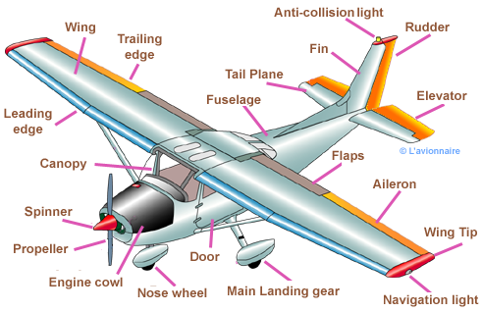
6. Interior Components: Seats, cockpit panels, interior trim.

The Enduring Importance of Pre-Flight Inspections
The significance of pre-flight inspections extends far beyond the immediate safety of the flight. They instill a sense of discipline and responsibility in pilots, fostering a deep understanding of the aircraft and its underlying systems. This heightened awareness translates into better decision-making and enhanced situational awareness during the flight, further contributing to the overall safety of the operation.
The Role of Checklists in Pre-Flight Inspections
To ensure the thoroughness and consistency of pre-flight inspections, pilots rely on comprehensive checklists, meticulously crafted to guide them through every step of the process. These checklists provide a sequential order of inspection points, ensuring that no critical component is overlooked.
The use of checklists not only enhances the effectiveness of pre-flight inspections but also mitigates the risk of human error. By following a standardized process, pilots are less prone to omissions or oversights, fostering a culture of precision and attention to detail.
The Impact of Pre-Flight Inspections on Accident Prevention
The meticulous nature of pre-flight inspections plays a pivotal role in preventing aviation accidents. By identifying and rectifying potential malfunctions before departure, pilots significantly reduce the likelihood of in-flight failures that could lead to catastrophic incidents.
Studies have consistently shown a strong correlation between pre-flight inspections and accident rates. A 2013 analysis by the Aviation Safety Network revealed that 80% of aviation accidents are attributable to human error, and pre-flight inspections are a critical factor in mitigating human error.

The Lasting Legacy of Pre-Flight Inspections
Pre-flight inspections represent a timeless practice in aviation, a testament to their unwavering importance in safeguarding the lives of passengers and crew. As aviation technology advances and aircraft become more sophisticated, the principles of pre-flight inspections remain as relevant as ever, ensuring that every flight commences with a commitment to safety and reliability.
Conclusion
In conclusion, pre-flight inspections are an indispensable element of aviation safety, serving as a cornerstone of the industry's commitment to ensuring the well-being of its passengers and crew. Through meticulous examination, consistent use of checklists, and unwavering attention to detail, pilots uphold the tradition of pre-flight inspections, ensuring that every aircraft takes to the skies with the highest standards of safety and readiness.


7. Exterior Components: Lights, antennas, doors.

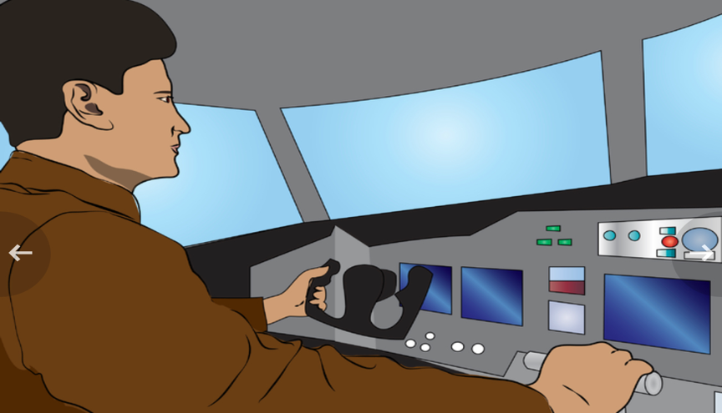
Ground control is a crucial component of air traffic
control (ATC) responsible for managing aircraft movements on the ground at airports. Their primary goal is to ensure the safe and efficient taxiing of aircraft between runways, terminals, gates, and other designated areas.
For pilots, key airport sections include the runway, taxiways, and apron for takeoff and landing, as well as the control tower for communication and guidance. Additionally, briefing on weather conditions and air traffic control information is crucial.

Key Responsibilities of Ground Control:

- Taxi Clearance: Ground control issues taxi clearances to aircraft, specifying the route they should follow on the ground. This clearance includes instructions for which taxiways and runways to use, as well as any other relevant information.

- Coordination with Tower and Other Controllers:
Ground control works in close coordination with the tower controller and other controllers to maintain overall control of aircraft movements in the airport's controlled airspace.

- Gate Assignment: Ground controllers assign gates or parking positions to arriving aircraft, ensuring efficient use of airport facilities.

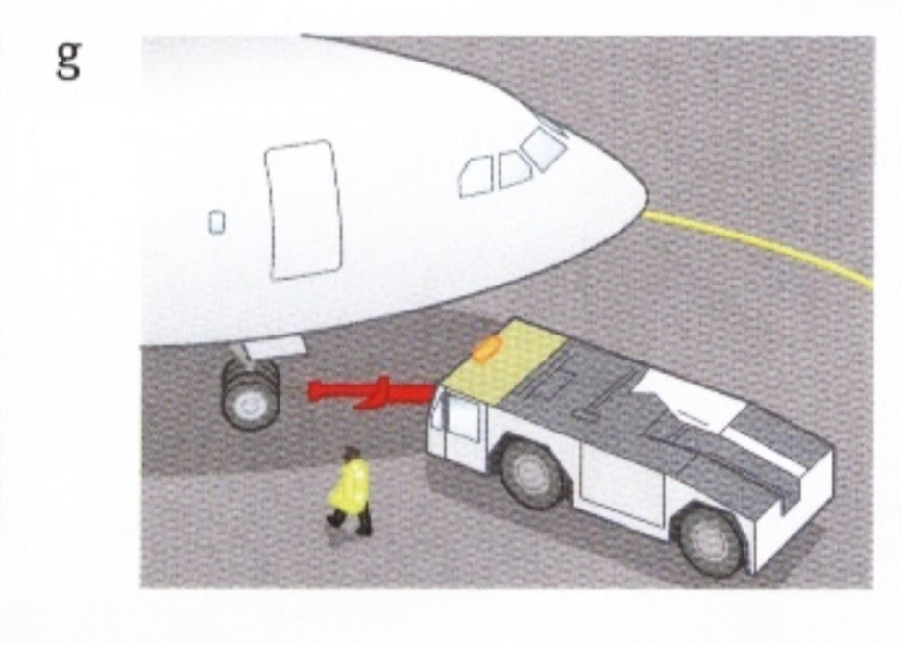
- Pushback Clearance: Before departure, aircraft typically require pushback from the gate. Ground control provides clearance for pushback and guides the aircraft away from the terminal area.

5- Runway Crossing Authorisation: When necessary, ground control authorises aircraft to cross active runways, coordinating with the tower to ensure it's done safely and without disrupting other traffic.

Radio Phraseology in Ground Communications:

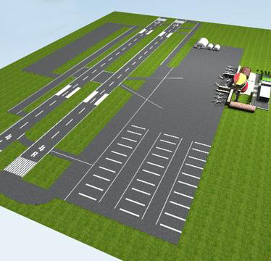
Pilots and ground controllers use standardized radio phraseology to ensure clear and concise communication. This includes:

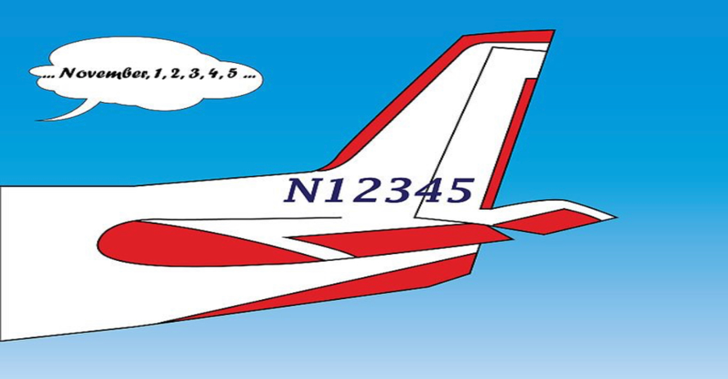
- Callsign: Aircraft and controllers use their assigned

callsigns for identification.

- Clearances: Clear and unambiguous instructions are given, such as "Taxi to Runway 27 via Alpha and Bravo."

- Acknowledgments: Pilots acknowledge instructions by repeating or reading back critical information to confirm understanding.

- Read-backs: Pilots are required to read back certain clearances, especially those related to runway assignments or changes.

- Monitoring Frequencies: Pilots monitor specific frequencies, switching between ground and tower frequencies as they taxi and take off.

Communication example on ground:

Pilot: “Malmo Ground, this is ABC123, stand 5, information Tango, ready to taxi.”

Ground Control: “ABC123, Malmö Ground, taxi to Runway 22 via taxiway Alpha and Bravo. Hold short of Runway 22 for landing traffic.”

Pilot: “Taxi to Runway 22 via Alpha and Bravo, hold short for landing traffic, ABC123.”

In this example:

• The pilot initiates contact, providing the aircraft’s callsign (ABC123), current location (stand 5), and the current ATIS information (Tango).
• Ground control responds with the taxi instructions, specifying the route (via taxiways Alpha and Bravo) and instructing the pilot to hold short of Runway 22 due to landing traffic.
• The pilot acknowledges the instructions, confirming the clearance and indicating awareness of the hold short instruction.




Departure communication for pilots involves crucial interactions between the flight crew and air traffic control (ATC) as an aircraft departs from an airport. Here are key aspects:

1. Clearance : Before departure, pilots receive their clearance from ATC. This includes information on the assigned runway, initial heading, initial altitude, and any specific departure procedures.

2. Taxi and Takeoff : Pilots communicate with ground control for taxi instructions to reach the assigned runway. Once at the runway, they switch to the tower frequency for takeoff clearance.

3. Initial Climb : After takeoff, the tower hands off the aircraft to the departure controller. Pilots report their heading and altitude as they climb, and departure control provides further instructions.

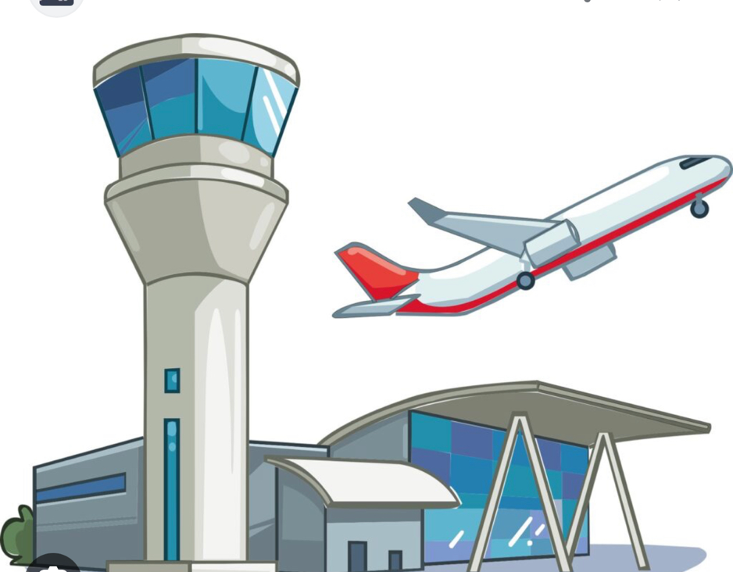
4. Handovers : As the aircraft progresses through different airspace sectors, communication is transferred from one controller to another.

Pilots acknowledge handovers and follow instructions for frequency changes.

5. En Route:During the initial climb and en route phase, pilots communicate with departure control regarding altitude changes, route clearances, and any adjustments to the flight plan.

Effective communication ensures safe and efficient departures, with pilots adhering to ATC instructions for navigation and altitude changes. It also allows controllers to manage traffic flow and provide timely instructions to ensure separation between aircraft.

Pilot Communications During Departure and Climb
Pilots must maintain clear and concise communication with air traffic controllers (ATCs) to receive clearances, instructions, and advisories. Additionally, pilots communicate with their co-pilots and other crew members to ensure coordinated actions and maintain situational awareness.
After takeoff, the pilot contacts departure control (DEP) to transition control from TWR. DEP provides initial heading and altitude instructions, ensuring separation from other aircraft and traffic conflicts.
As the aircraft climbs, DEP may hand off control to center control (CTR), responsible for en route traffic management. CTR coordinates with other centers to ensure smooth and efficient traffic flow.
Cruise Communications
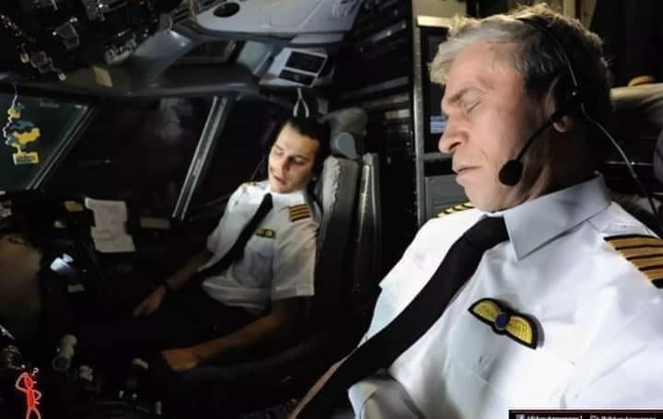

During cruise, pilots maintain periodic communication with en route ATCs, typically every 10-15 minutes. These routine position reports provide ATCs with updates on the aircraft's location, altitude, and estimated time of arrival (ETA) at specific waypoints.
ATCs may issue altitude changes or course deviations to avoid weather, traffic congestion, or airspace restrictions. Pilots promptly acknowledge and comply with ATC instructions.
In case of emergencies or unexpected situations, pilots initiate immediate communication with ATC, providing a clear description of the situation and requesting assistance or clearance for diversionary actions.

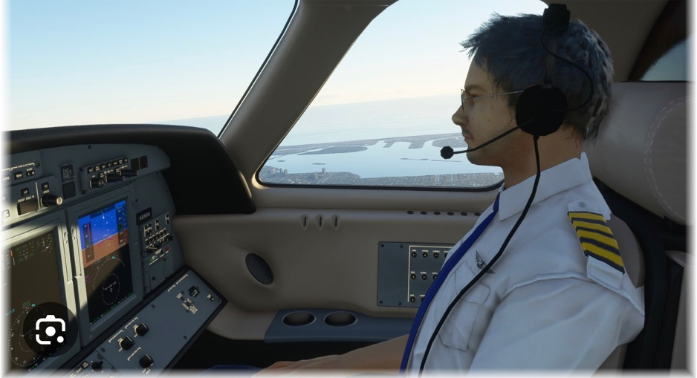
Certainly, durin the cruise phase of flight, pilots engage in various types of communication. Here are some examples:

1. ATC Position Reports:
• Pilots report their position to air traffic control (ATC) at specified intervals. These reports include information about the aircraft’s current location, altitude, and other relevant details. A pilot position report during cruise typically includes key information about the aircraft’s current status. Here’s an example:

Pilot: “Center, ABC123, level flight FL350, estimating FIXIT waypoint at 1330 Zulu, TAS 480 knots, next waypoint PANTA, request further clearances.”

In this example:

• ABC123: Aircraft callsign.
• Level flight FL350: The aircraft is maintaining a level flight at an altitude of 35,000 feet.
• Estimating FIXIT waypoint at 1330 Zulu: The pilot provides an estimate of when they will reach a specific waypoint (FIXIT) in Coordinated Universal Time (Zulu).
• TAS 480 knots: True Airspeed of the aircraft is 480 knots.
• Next waypoint PANTA: Informs the controller of the next waypoint along the route.
• Request further clearances: Indicates the pilot is ready for additional instructions or clearances from air traffic control.

Actual position reports can vary based on specific procedures, airspace requirements, and the preferences of the controlling agency. Pilots communicate this information to keep air traffic control informed about their progress and to facilitate safe and efficient air traffic management during the cruise phase
.
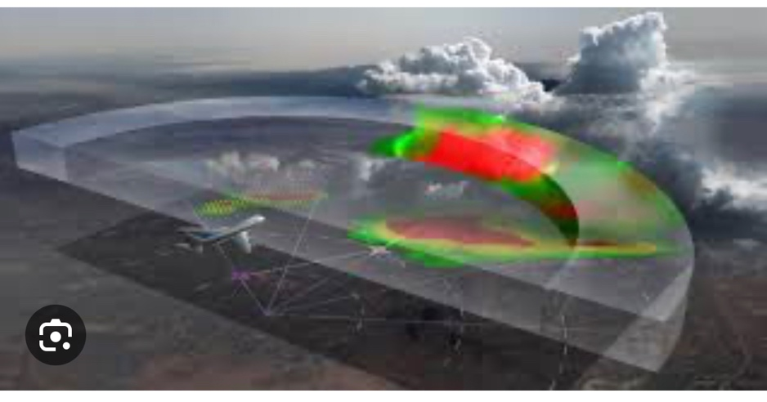
2. Weather Updates:

• Pilots may communicate with ATC or the airline’s operations center to receive weather updates along their route. This information helps them anticipate and navigate through any weather-related challenges.

3. Crew Communication:

• Pilots communicate with each other to discuss the flight plan, review systems status, and coordinate any necessary actions. This communication helps maintain a shared understanding of the flight’s progress.

4. Passenger Announcements:

• Pilots make periodic briefings to update passengers on the flight’s progress, expected arrival times, and any notable information about the journey.

5. Navigation and Route Changes:

• If necessary, pilots communicate with ATC to request or inform about changes to their planned route. This might be due to factors like weather, traffic, or operational considerations
.
6. Fuel Management:

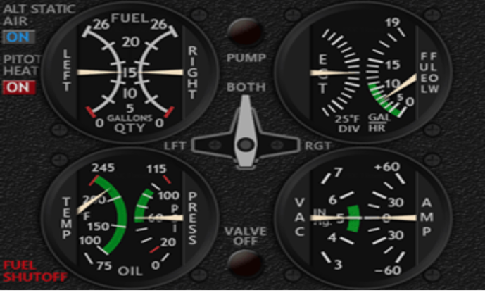
• Pilots communicate with the operations center or dispatch to provide updates on fuel consumption and discuss any adjustments needed for efficient fuel management.

7. Emergency Communication:

• While rare, if there are any emergency situations or irregularities, pilots communicate with the relevant authorities or ATC to coordinate appropriate responses.

Effective communication during the cruise phase is essential for the overall safety and efficiency of the flight, ensuring that the aircraft operates smoothly throughout its journey.


Chapter 1: Pilot Approach Communication
Introduction
Pilot approach communication is the vital exchange of information between pilots and air traffic controllers (ATCs) during the approach phase of flight, which is the critical transition from en route to landing. Effective communication during this stage is paramount for ensuring the safety and efficiency of air operations.
Purpose of Approach Communication
The primary purpose of approach communication is to convey essential information that facilitates a safe and orderly approach to the runway. This information includes:
- Aircraft identification and position: Pilots communicate their aircraft's callsign, altitude, and position to ATCs, allowing ATCs to maintain situational awareness and prevent conflicts.
- Clearances and instructions: ATCs issue clearances and instructions to pilots, guiding them through the approach sequence, including headings, altitudes, and airspeeds.
- Weather conditions: ATCs provide pilots with current and forecasted weather conditions, enabling pilots to make informed decisions about their approach and landing.
- Traffic advisories: ATCs inform pilots of other aircraft traffic in the vicinity, helping to avoid potential conflicts and maintain separation.
Standard Phraseology
To ensure clarity and standardization, pilots and ATCs adhere to a set of standard phraseology during approach communication. This shared language minimizes misunderstandings and promotes efficient information exchange.
Key Elements of Effective Approach Communication :
Effective approach communication encompasses several key elements:
- Clarity and conciseness: Pilots and ATCs should communicate clearly and concisely, using standard phraseology and avoiding unnecessary jargon.
- Active listening: Both pilots and ATCs must actively listen to each other's transmissions, ensuring that all messages are understood and acknowledged.
- Professionalism: Approach communication should be conducted in a professional and courteous manner, even in challenging situations.
- Readbacks: Pilots should read back clearances and instructions to confirm their understanding and reduce the risk of errors.
- Questioning: Pilots should not hesitate to ask questions if they have any doubts or uncertainties regarding instructions or procedures.


Challenges in Approach Communication
Despite the importance of effective approach
communication, several challenges can arise:
- Language barriers: Pilots and ATCs may not share the same native language, which can lead to misunderstandings.
- Noise and interference: Radio transmissions can be affected by noise and interference, making it difficult to hear and understand messages clearly.
- Workload and stress: Pilots and ATCs often operate under high workloads and stress levels, which can impact their communication effectiveness.
Mitigating Communication Challenges
Several strategies can help mitigate communication challenges:
- Proficiency in standard phraseology: Pilots and ATCs should be proficient in standard phraseology to ensure clear and concise communication.
- Use of English as the common language: The use of English as the common language of aviation helps minimize language barriers.
- Redundancy and repetition: Pilots and ATCs should use redundancy and repetition in their transmissions to increase the likelihood of messages being received and understood.
- Clearance confirmation: Pilots should always confirm receipt and understanding of clearances to reduce the risk of errors.
Conclusion :
Pilot approach communication plays a critical role in ensuring the safety and efficiency of air operations. By adhering to standard phraseology, practicing active listening, and maintaining professionalism, pilots and ATCs can effectively communicate essential information during the approach phase, contributing to a safe and successful landing.

Landing Communication for Pilots
Effective communication between pilots and air traffic control (ATC) is paramount to ensuring the safe and efficient operation of aircraft. During the landing phase, this communication becomes even more critical, as pilots and ATC must coordinate traffic and ensure that aircraft are positioned correctly for a smooth landing.
Establishing Initial Contact
Upon reaching the destination airport, pilots typically establish initial contact with ATC approximately 30-40 miles from the airfield. This contact is initiated by the pilot stating the aircraft's callsign, followed by the type of approach they intend to use, the runway they will be landing on, and their current altitude. For example:
Pilot: Approach, Cessna 1234, inbound for runway 36, VFR, 3,500 feet.
ATC: Cessna 1234, Approach, radar contact. Squawk 1234. Report when over the outer marker.
The ATC controller then issues a squawk code, a four-digit number that the pilot enters into their transponder. This code allows ATC to identify and track the aircraft on their radar screens.
Approach Phase Communications:
As the aircraft descends and maneuvers towards the runway, the pilot and ATC continue to communicate, exchanging information about altitude, heading, and any changes in flight path or instructions. These communications are crucial for ensuring that the aircraft maintains a safe distance from other traffic and complies with ATC clearances.
Pilot: Approach, Cessna 1234, over outer marker, descending to 2,500 feet, established on the localizer.
ATC: Cessna 1234, Approach, cleared for the ILS approach. Runway 36, cleared to land.
Once cleared for the approach, the pilot continues to descend and follow the instrument landing system (ILS) guidance, which provides precise lateral and vertical guidance for landing.
Final Approach and Landing Communications :
In the final phase of the approach, the pilot communicates with ATC as they turn onto the final approach course and begin their descent towards the runway. ATC may issue additional instructions or clearances, such as vectors to intercept the final approach course or guidance to maintain a specific landing speed.
Pilot: Approach, Cessna 1234, turning onto the final approach course, descending to 1,000 feet.
ATC: Cessna 1234, Approach, maintain visual contact with runway. Cleared to land.
Post-Landing Communications :
After landing, the pilot continues to communicate with ATC, reporting their position and intentions. This includes taxiing to the designated parking area, requesting taxi instructions, and notifying ATC when they are ready to depart.
Pilot: Ground, Cessna 1234, cleared to taxi to parking position Charlie.
Ground: Cessna 1234, taxi to the right, follow the blue taxiway to parking position Charlie.
Pilot: Roger, Ground, Taxiing to parking position Charlie.

Communicating Emergencies :
In an emergency situation, pilots must immediately inform ATC using the emergency phrase "Mayday, Mayday, Mayday." This alerts ATC to the situation and allows them to take immediate action to assist the aircraft.
Pilot: Mayday, Mayday, Mayday, Cessna 1234, declaring an emergency. Engine failure, unable to maintain altitude.
ATC: Cessna 1234, Mayday, Mayday, Mayday. Squawk 7700. Acknowledge.
Pilot: 7700.
ATC will then provide assistance to the aircraft, coordinating with other aircraft and emergency services to ensure a safe landing or diversion to an alternate airport.
Technological Advancements in Pilot Communication
Technological advancements have enhanced pilot communication, including:
- Data Link Communications (Datalink): Allows pilots to exchange text messages with ATCs, reducing voice congestion and improving clarity.
- Automatic Dependent Surveillance-Broadcast (ADS-B): Provides real-time aircraft position and status information to ATCs, enhancing situational awareness.
- Controller Pilot Data Link Communication (CPDLC): Enables pilots to receive and accept clearances directly from ATCs through datalink, streamlining communication.
These advancements have improved communication efficiency, reduced workload, and enhanced safety during departure and cruise phases of flight.

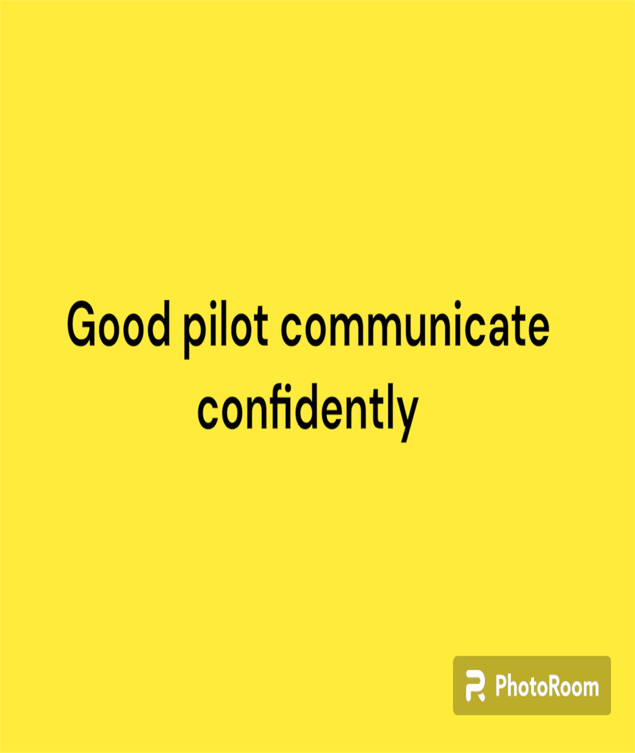




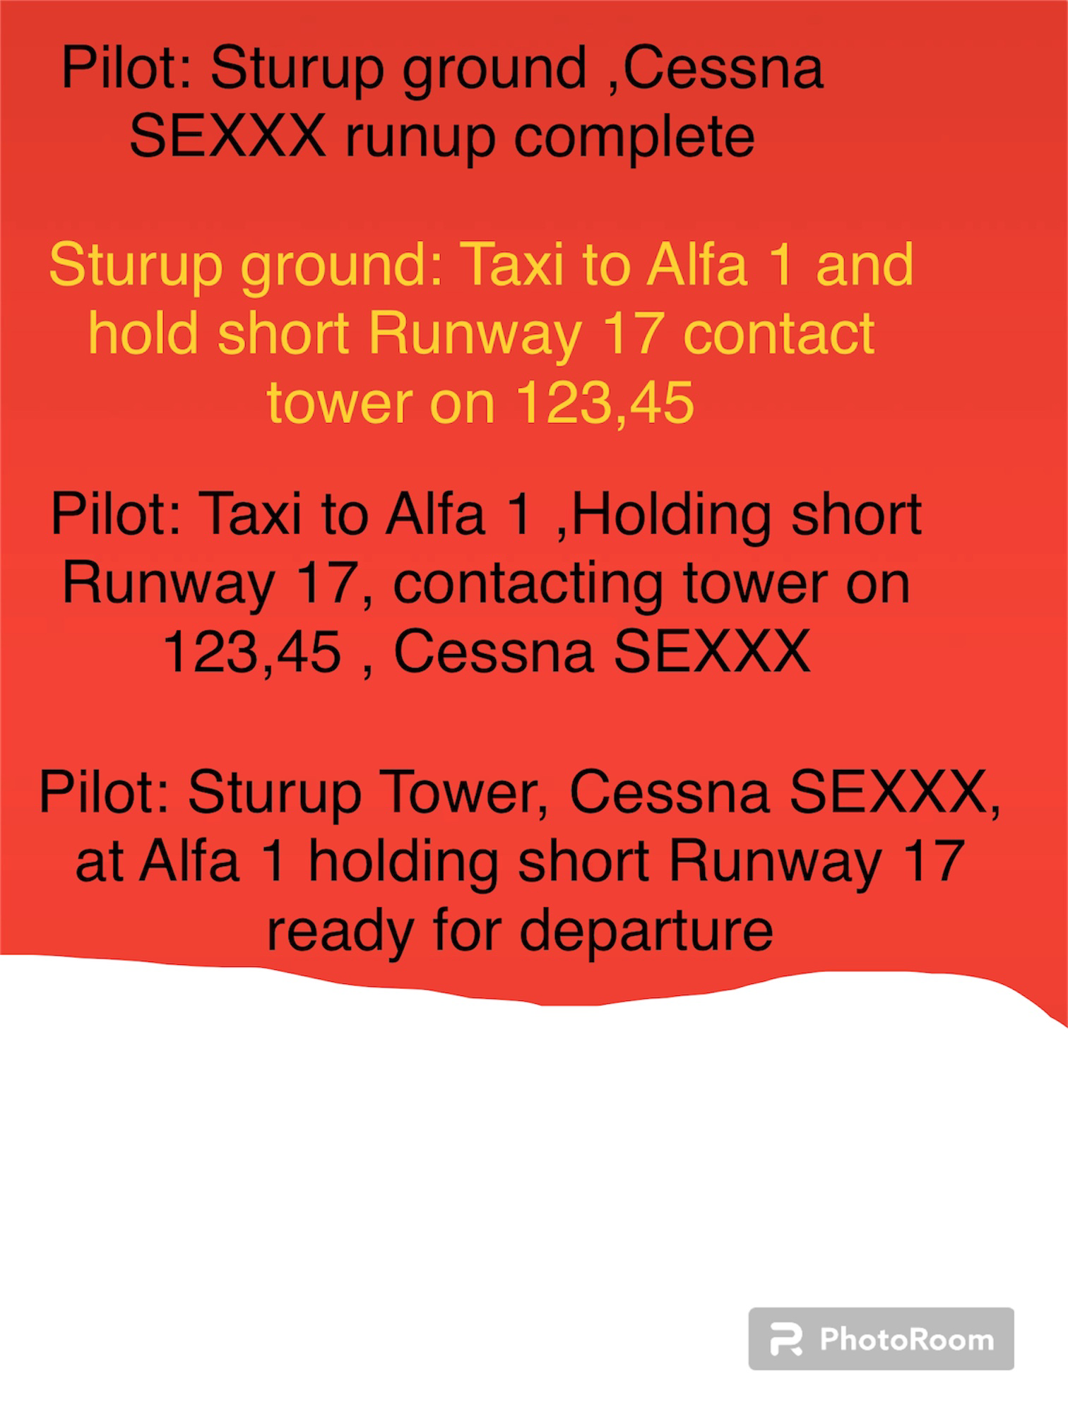

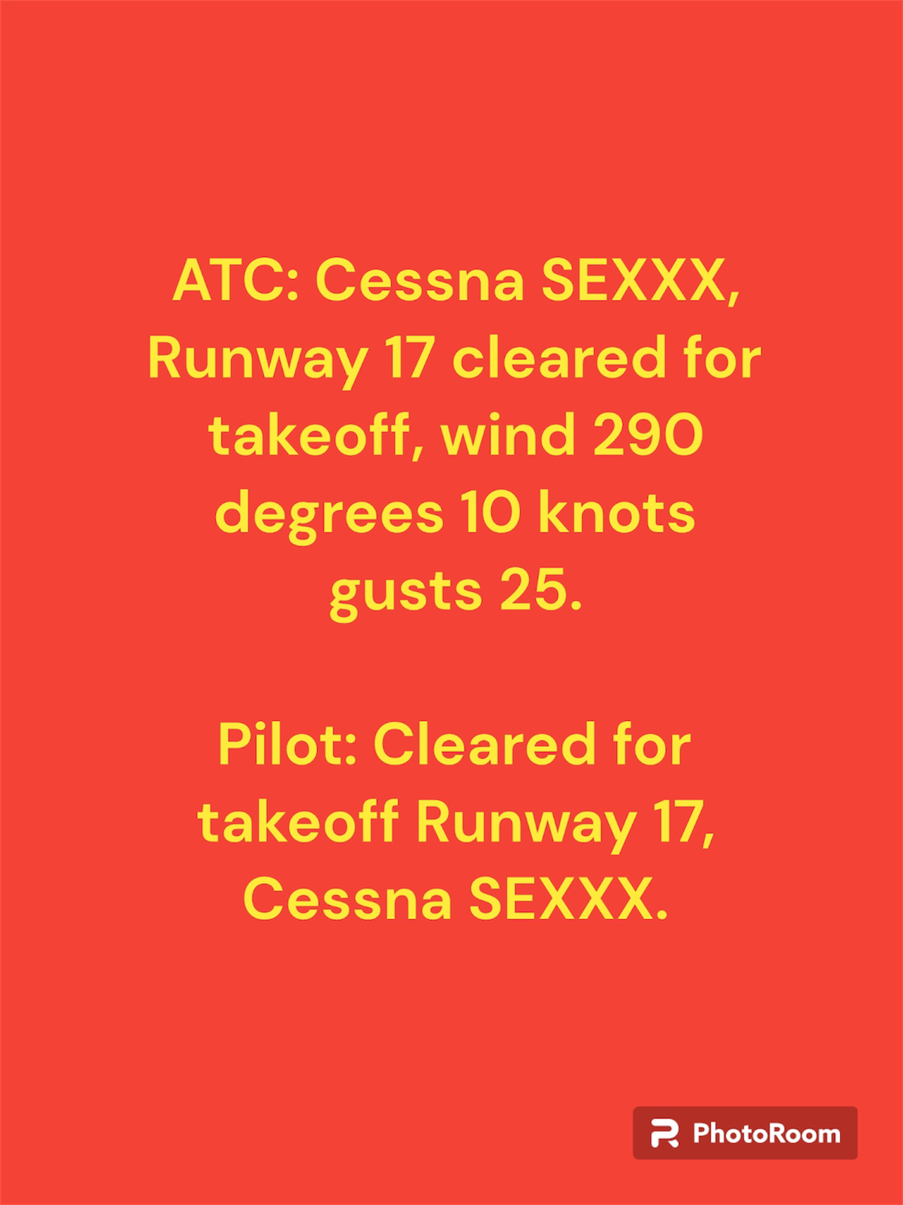

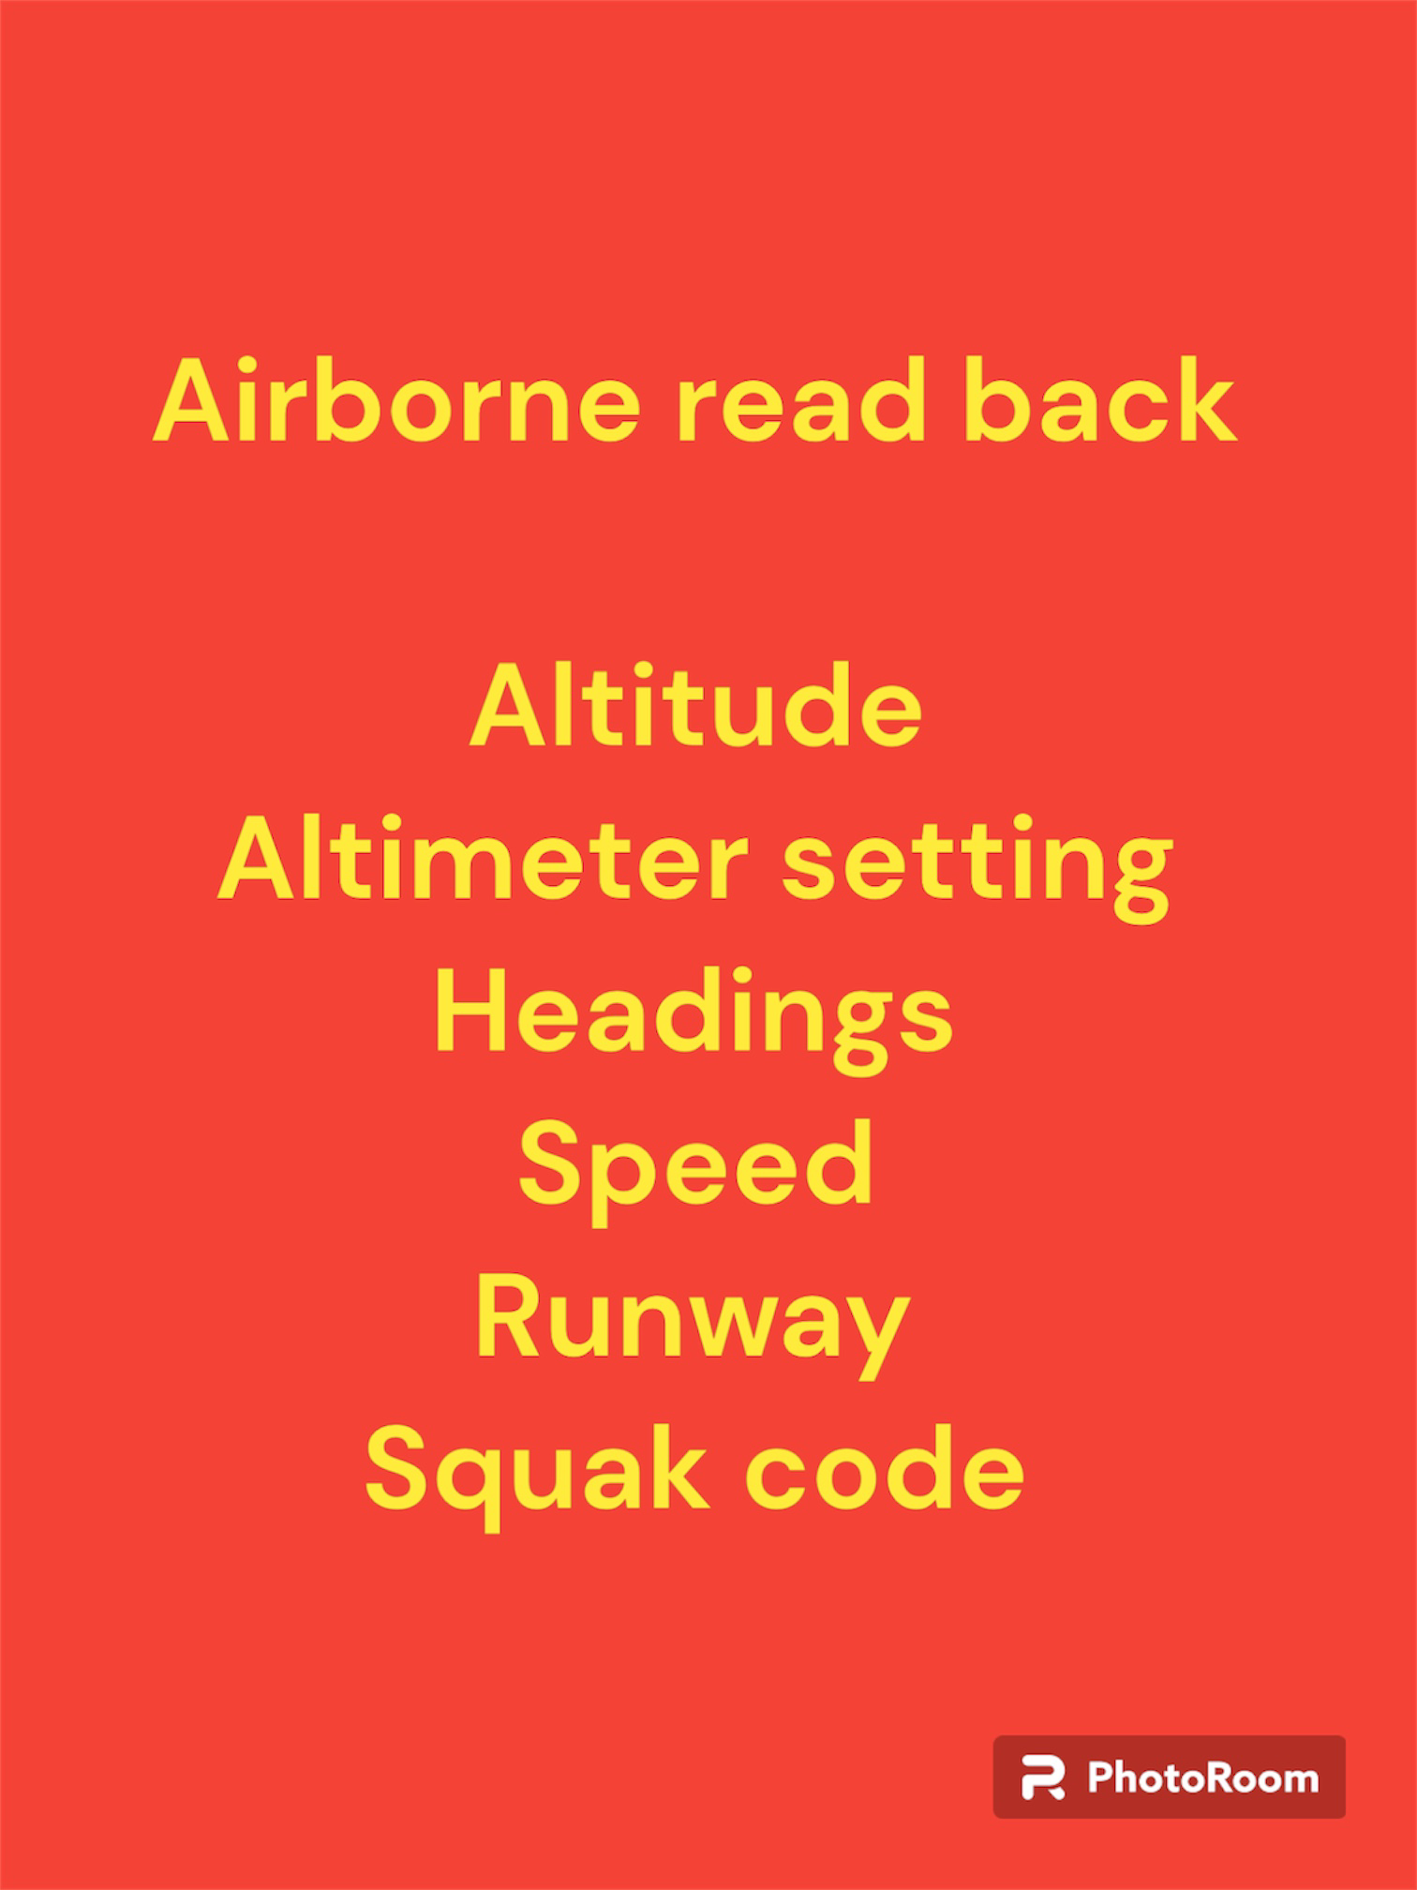

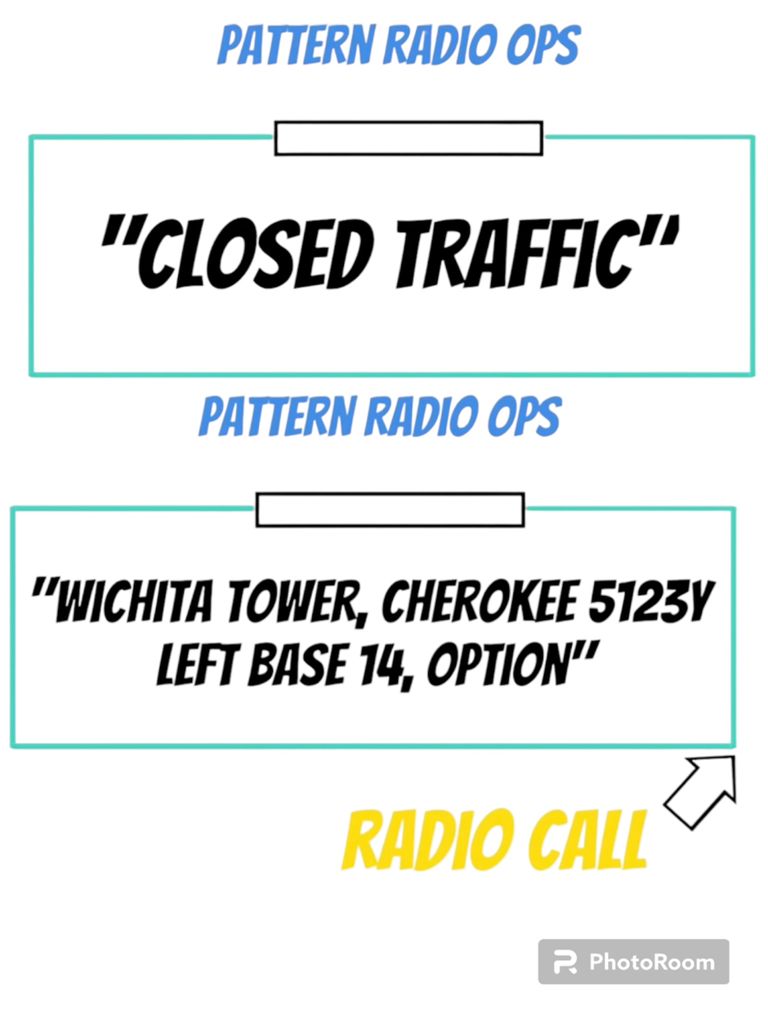
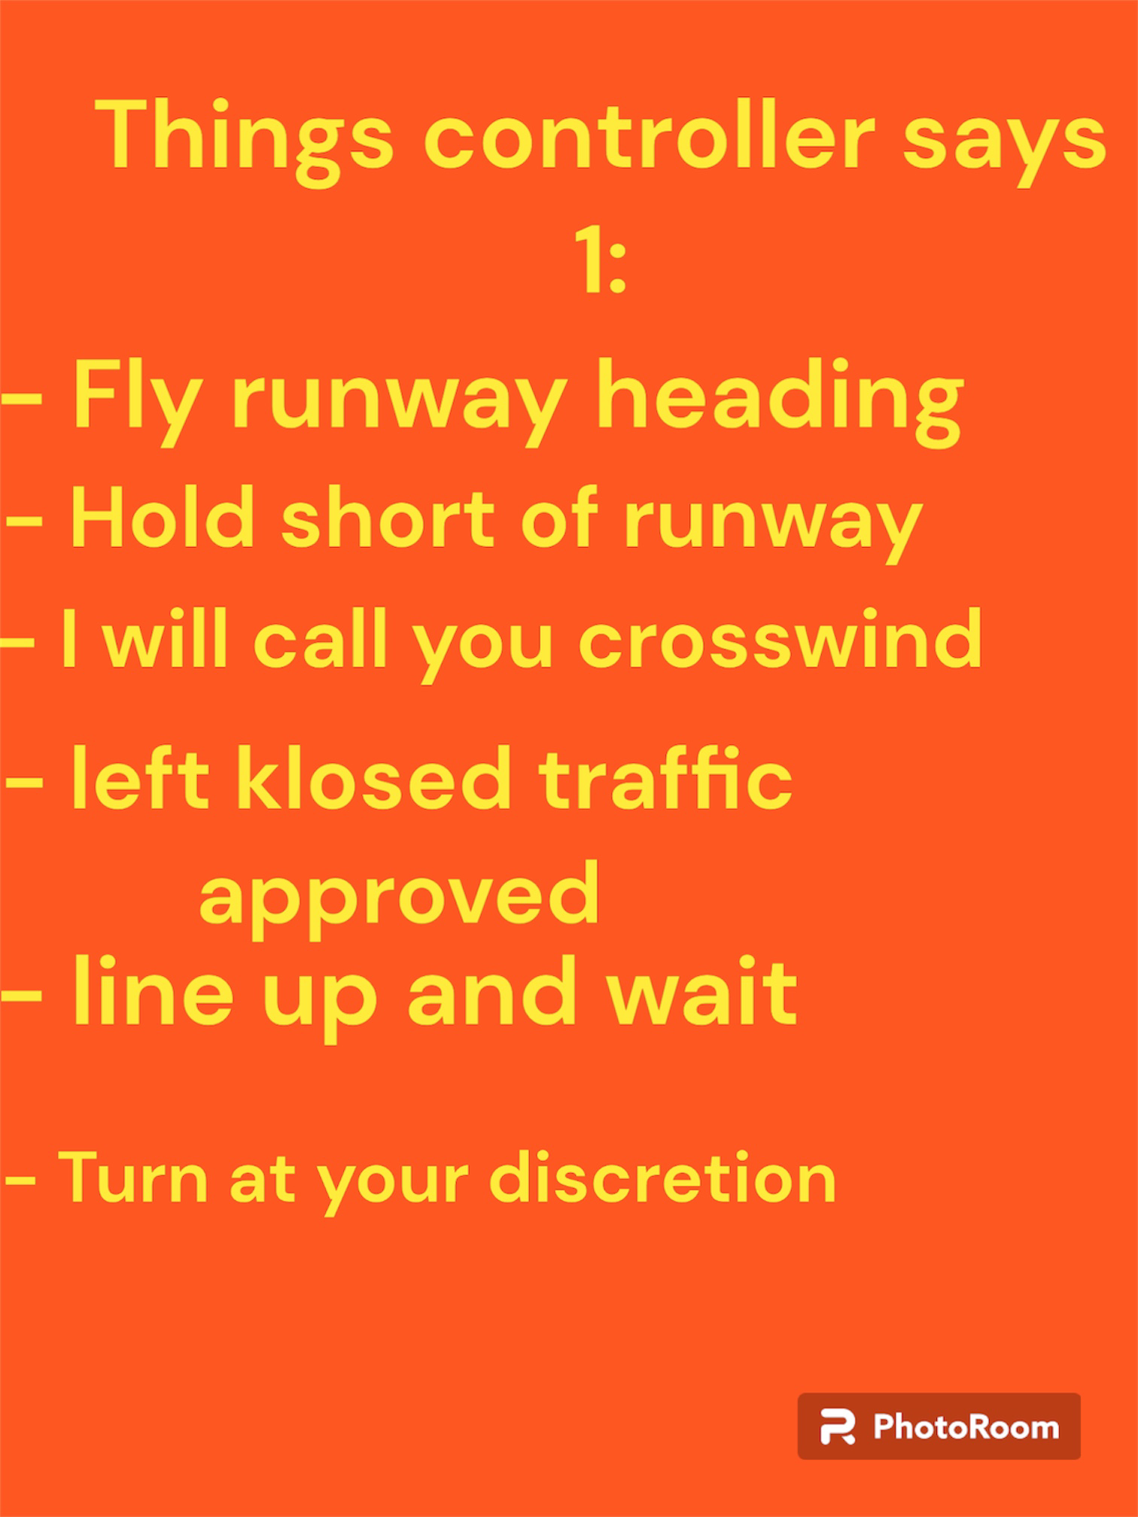
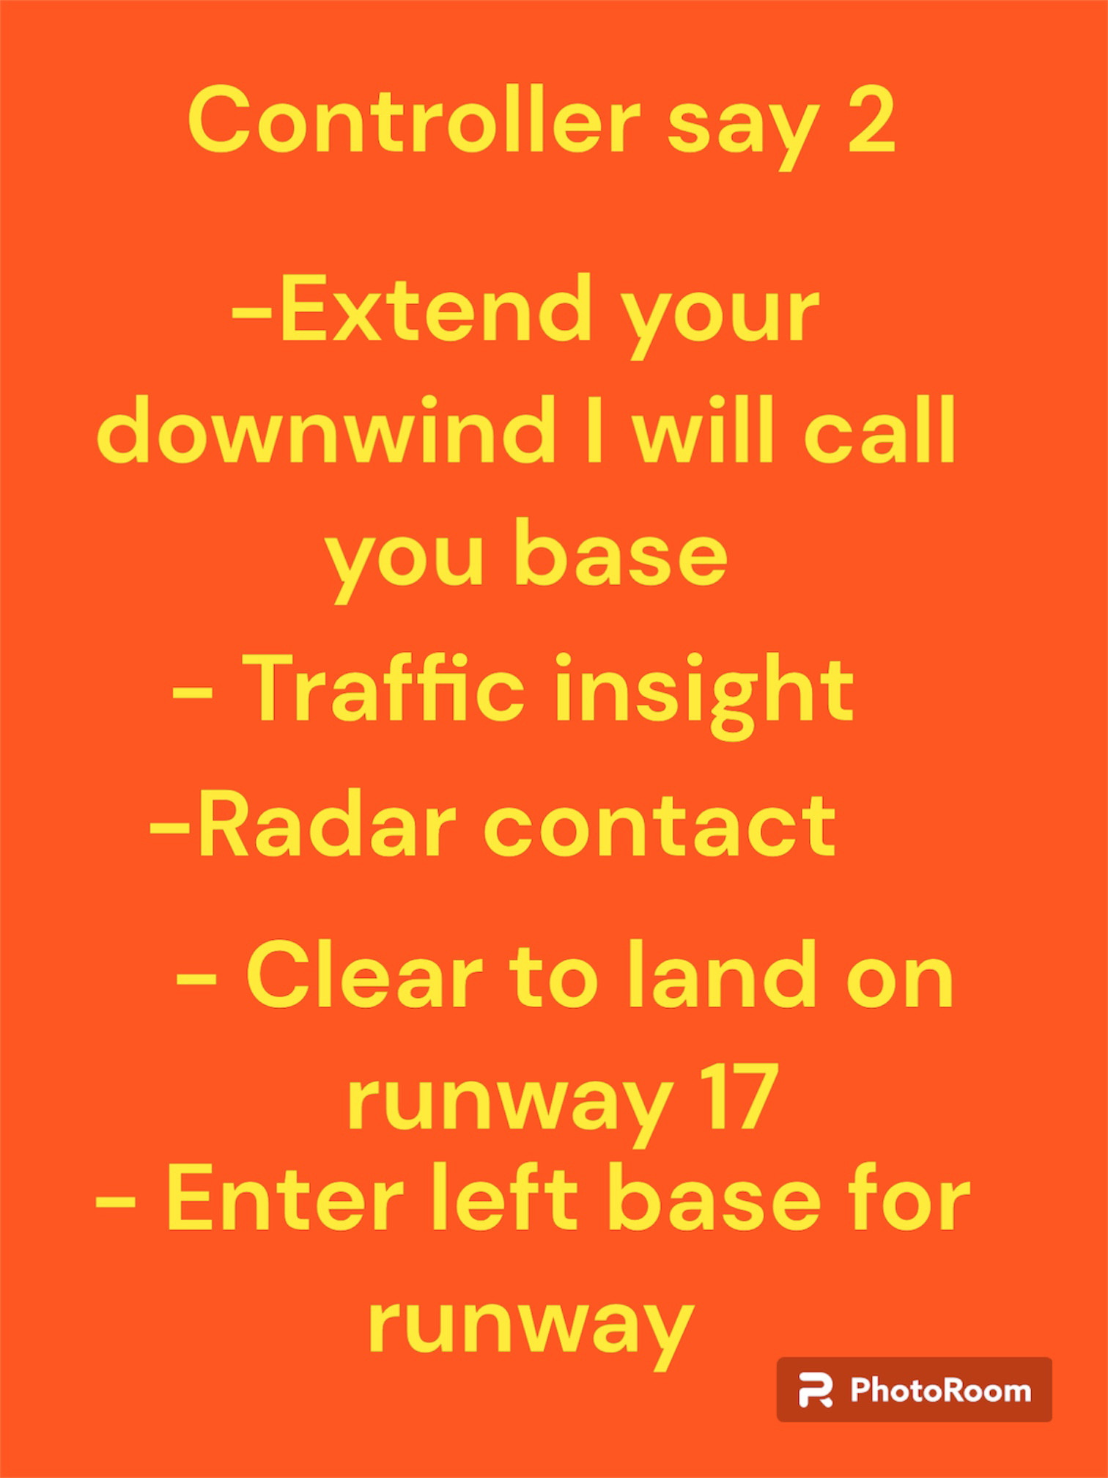


Thank you

Copy right reserved 2023

